A Minor Project Proposal on
ELECTRAMETRICS (मत-सूचक AI)
Submitted in partial fulfillment of the requirements for the degree of
Bachelor of Engineering in Software Engineering at Pokhara University

By
ASHUTOSH PARAJULI
BENJU POKHREL


Department of Research and Development
GANDAKI COLLEGE OF ENGINEERING AND SCIENCE
Lamachaur, Kaski, Nepal
(May, 2026)

A Minor Project Proposal on
ELECTRAMETRICS (मत-सूचक AI)
Submitted in partial fulfillment of the requirements for the degree of
Bachelor of Engineering in Software Engineering at Pokhara University

By
ASHUTOSH PARAJULI
BENJU POKHREL

Supervisor
SUPERVISOR NAME

Department of Research and Development
GANDAKI COLLEGE OF ENGINEERING AND SCIENCE
Lamachaur, Kaski, Nepal
(May, 2026)

APPROVAL CERTIFICATE
This project entitled "ELECTRAMETRICS (मत-सूचक AI)" prepared and submitted by "Ashutosh Parajuli and Benju Pokhrel" under the supervision of "teacher name" in partial fulfillment of the requirements for the Degree of Bachelor of Engineering in Software Engineering has been examined and is recommended for approval and acceptance.

Date of Evaluation: May 26, 2026

……………………………………
Supervisor’s name
(Project Supervisor)

…………………………………
Er. Rajendra Bahadur Thapa
Project Head
Research Management Committee
Gandaki College of Engineering and Science

ABSTRACT
This project purposes on developing a digital platform to track and visualize the public opinion for elections in local governments in Nepal. Rather than conducting surveys, the application automatically scrapes public opinions and news headlines from YouTube, Tiktok, Google News, and Twitter/X according to a set schedule. Given that the discussions in Nepal combine English, Nepali, and the local internet language known as "Nepglish," the application processes the language. Using the results obtained from a machine learning algorithm, it calculates a percentage ratio between positive and negative reactions toward candidates. By aggregating the ratios, the system determines which candidate or political party leads the digital trend in the city. The digital map of the trend shows five major cities: Pokhara, Kathmandu, Chitwan, Dhangadhi, and Dharan. Each area on the map gets colored with the official color of the political party leading the trend. The application serves as a convenient visualization tool for political analysts and media teams.

TABLE OF CONTENTS
APPROVAL CERTIFICATE iii
ABSTRACT………………………………………………………………...
TABLE OF FIGURES………………………………………………………
LIST OF TABLE……………………………………………………………
CHAPTER 1 1
INTRODUCTION 1
1.1. BACKGROUND 1
1.2. PROBLEM STATEMANT…………………………………………..
1.3. OBJECTIVE…………………………………………………………
1.4. IMPLICATION………………………………………………………
CHAPTER 2…………………………………………………………………
LITERATURE REVIEW…………………………………………………..
CHAPTER 3…………………………………………………………………
TOOLS AND METHODOLOGY
3.1. REQUIRED TOOLS
3.2. APPROACH USED
3.3. USE CASE DIAGRAM
3.4. SYSTEM SEQUENCE DAGRAM (SSD)
3.5. ENTITY RELATIONSHIP DIAGRAM
CHAPTER 4
Expected Outputs
CHAPTER 5
TIMELINE CHART
BIBLIOGRAPHY 2

CHAPTER 1

INTRODUCTION

1.1 BACKGROUND

In the last few years the Government and People of Nepal have begun using social media as part of the political process, using it as part of the election campaigns. Current political polling in Nepal uses physical surveys or Phone Parties to gain insights into political trends. Typically, these are complex, expensive and time-consuming to execute and provide no access to real-time internet trends. With improvements in machine learning technology and dynamic digital mapping, it is now possible to build automated systems that aggregate, clean and visualize the sentiment of the public directly from the social media source data. The result is a simplified, easily digestible representation of interesting public trends within a political map.

1.2 PROBLEM STATEMENT

The main aim of this project is to create a web portal which can systematically extract public opinions via social media platforms to map public opinion concerning local elections in Nepal. This would involve processing public opinion in the form of internet slang (Roman) obtained from YouTube, TikTok, Google News, and Twitter/X to obtain a candidate’s winning probability score. Finally, it will automatically project these shifting political trends onto an interactive digital map of five major cities : Pokhara, Kathmandu, Chitwan, Dhangadhi, and Dharan by color-coding municipal boundaries to replace slow and expensive physical surveys.
1.3. OBJECTIVE
For many political experts, media agencies, and people at large, it is difficult to monitor the mood of the population due to the fact that conventional surveys conducted offline are very time-consuming and fail to catch rapid shifts in voter mood. Currently available online sentiment analysis tools are unable to accommodate local slang (i.e. Nepglish) and cannot relate the results to particular geographic locations. Most importantly, a lack of a comprehensive system that can combines multi-platform data collection, slang cleanup, and interactive map visualization creates a major barrier, leaving stakeholders without a reliable way to understand real-time voter trends in local municipalities.
1.4. IMPLICATION
This platform has the potential to revolutionize the way people track and analyze public opinion by providing an approach that would provide the means of changing how people go about assessing and analyzing public opinions through its user-friendly, smart, and interactive nature. Analysts and citizens who may not have much technical know-how can be able to take charge of the data analysis process, avoid incurring costly physical surveys, and make sound decisions when voting. Media houses, election managers, and political analysts can also use this tool as a powerful mechanism to plan for elections ahead of time.

CHAPTER 2
LITERATURE REVIEW
Several tools, specialized datasets, and academic research papers have been developed to handle sentiment analysis, text processing in local contexts, and geographic mapping. This chapter reviews five specific systems and methodologies, highlights their features and limitations, and details their direct relevance to our proposed system.
NepCOV19Tweets and NepEMO Datasets
The NepCOV19Tweets and NepEMO datasets are pre-labeled, publicly available academic data collections built by local researchers. They consist of thousands of localized social media posts categorized into positive, negative, or neutral feelings, along with discrete emotional states.
Main Strength: They provide an excellent baseline for training machine learning algorithms because they contain real-world text patterns specific to the Nepalese digital space.
Limitation: These datasets are entirely static. Furthermore, while they contain a significant amount of text written in the Roman script, they do not include an automated system to clean up or standardize mismatched spelling variations or casual internet shorthand before classification.
Relevance: Our project directly utilizes these datasets to train our Scikit-Learn (Logistic Regression/Linear SVM) pipeline. We extend their utility by adding a custom text normalizer to clean up messy Roman text before it enters the model.
Commercial Multi-Platform Sentiment Trackers (e.g., Brand24, Talkwalker)
Commercial brand-monitoring platforms automatically scan global social media networks, including Twitter/X, TikTok, and YouTube, to aggregate public opinions and generate sentiment graphs.

Main Strength: They possess highly efficient background workers that safely handle data scraping and API restrictions from multiple platforms simultaneously.
Limitation: Their built-in language processors are optimized for standard English or major global languages. They are completely unable to interpret unstructured sentences written in the Roman script, nor can they parse regional political context. This causes them to misclassify or completely ignore local Nepalese election data.
Relevance: Our system mimics their robust multi-platform collection architecture by utilizing background Flask workers to scrape YouTube, TikTok, Google News, and Twitter/X, but replaces their generic language engines with a classifier built specifically for local text.
Standard TF-IDF and Logistic Regression Pipelines in Academic Papers
Many computer science research papers in Nepal focus on using Term Frequency-Inverse Document Frequency (TF-IDF) feature extraction paired with Logistic Regression or Linear Support Vector Machines (SVM) to classify local language text.
Main Strength: These machine learning combinations are lightweight, consume very little memory, process text fast, and achieve high mathematical accuracy when dealing with small, localized datasets.
Limitation: In almost all published papers, these models exist only inside isolated Google Colab files used for academic reporting. They are never exported into production-ready software or connected to automated web-scraping scripts.
Relevance: Our project bridges this exact gap. We train the lightweight TF-IDF and Logistic Regression pipeline inside a Google Colab, export the finalized logic into a serialized model file (election_sentiment_model.pkl), and load it natively inside a live Flask web application thread.
Post-Election Static GIS Maps (Election Commission of Nepal Data)
Political analysts and geographic researchers use traditional Geographic Information System (GIS) tools to map final voter counts across different voting districts after an election concludes.

Main Strength: They provide highly accurate, official geographic representations of political party distributions using clear, standard party colors.
Limitation: These maps are entirely static and manual. They are generated months after an election end using finalized physical paper counts, making them completely incapable of tracking shifting public mood or calculating winning probabilities before election day.
Relevance: Our system adopts the visual clarity of geographic boundary maps but introduces dynamic updates. Instead of waiting for final paper counts, our Leaflet.js map engine reads live municipal GeoJSON files and shades them dynamically based on ongoing digital data.
Local Election Digital Dashboards (e.g., International Media Election Trackers)
Major international news networks deploy interactive web dashboards during major global elections, utilizing interactive maps to show shifting candidate leanings across states or municipalities.
Main Strength: They provide an excellent, user-friendly frontend experience where regional boundaries shade themselves dynamically based on probabilistic polling data.
Limitation: These systems rely on massive, multi-million-dollar physical polling networks and advanced digital architectures that do not exist for local government levels in Nepal. They are completely unavailable for specific municipal mayor races.
Relevance: Our project scales down this high-level interactive map experience for a local context. We apply this visual dashboard approach specifically to five major municipal areas in Nepal—Pokhara, Kathmandu, Chitwan, Dhangadhi, and Dharan—replacing expensive polling networks with automated social media tracking.

CHAPTER 3
TOOLS AND METHODOLOGY
3.1. REQUIRED TOOLS
For the development of the project, various software development kits, frameworks, and libraries are necessary. These tools are categorized into software environments, backend components, frontend visualization tools, and data processing libraries as follows:
Table 1: TOOLS
S.N | TOOLS | USES
1 | HTML | To build the structure of the dashboard and user interface panels.
2 | CSS | To design layout styles, map responsive grids, and party theme indicators
3 | JavaScript | To fetch local data files, handle user interactions, and run map events
4 | Leaflet.js | To render the interactive map and dynamically change city border colors based on sentiment themes
5 | Python | To run offline web scrapers for extracting comments and process NLP data pipeline task
6 | Google Colab | To load datasets, clean text noise, and train the machine learning classification pipeline
7 | Scikit-Learn | To implement TF-IDF text feature extraction and train the Logistic Regression classification model
8 | JSON | To act as the file format data bridge that passes processed sentiment scores directly into the map script

3.2. APPROACH USED
The Agile model is a flexible and iterative approach to software development that emphasizes collaboration, adaptability, and customer feedback. Instead of following a rigid, linear process, Agile breaks the project into smaller increments called sprints, allowing for continuous development, testing, and refinement. This model ensures faster delivery of functional components, enhances team collaboration, and enables quick responses to changing requirements or market trends. By using the Agile model, our house design platform development will stay efficient, user-centered, and flexible to adapt to changing requirements and feedback.
The stages of Agile project management generally follow this sequence:
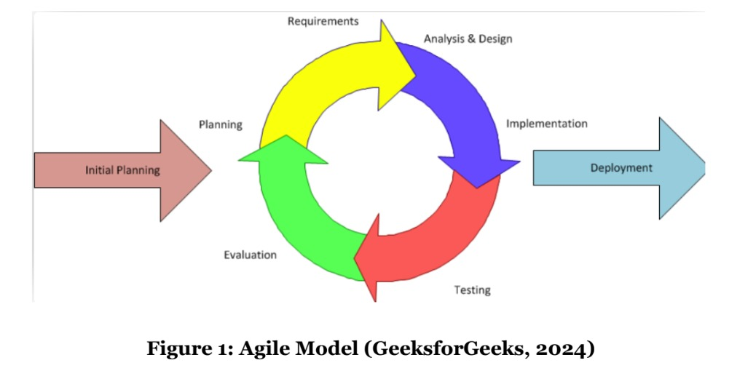
- Planning & Requirements:
Discuss among team members on the topic of what needs to be done and how it will be done.
- Analysis & Design:
Generate required models and elements in the process and import it.
- Implementation:
Use the model in the code base to generate the required output.

- Testing:
Test the model's functionality and debug if requirement doesn't meet.
- Evaluation:
Evaluate the work progress done by each team member.

3.3. USE CASE DIAGRAM
A use case diagrams is a method of summarizing information about a system and its users. It is typically portrayed as a graphical representation of interactions between various elements in a system. Use case diagrams describe the events in a system and how they flow, but they do not describe how those events are implemented.
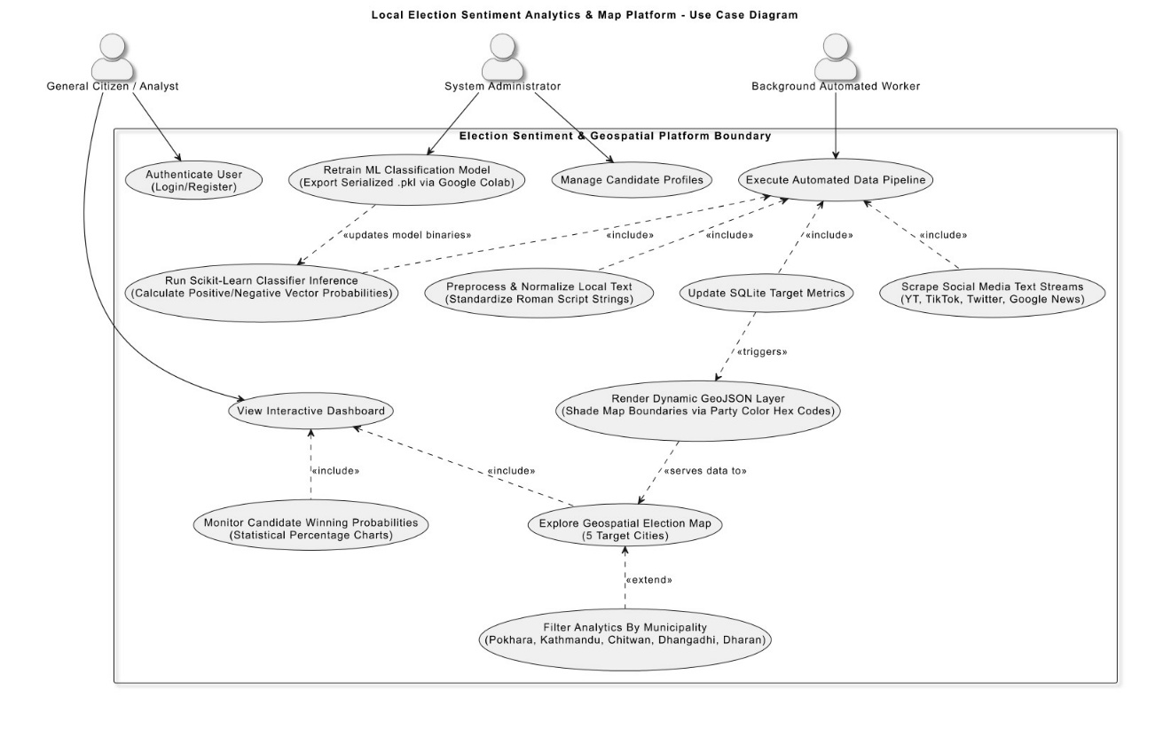
3.4. SYSTEM SEQUENCE DIAGRAM (SSD)
Sequence Diagrams are interaction diagrams that show how operations take place. They record the interaction of objects within the context of a collaboration. Sequence Diagrams are time focused, and they visually represent the order of the interaction by using the vertical axis of the diagram to represent time, what messages are sent, and when.
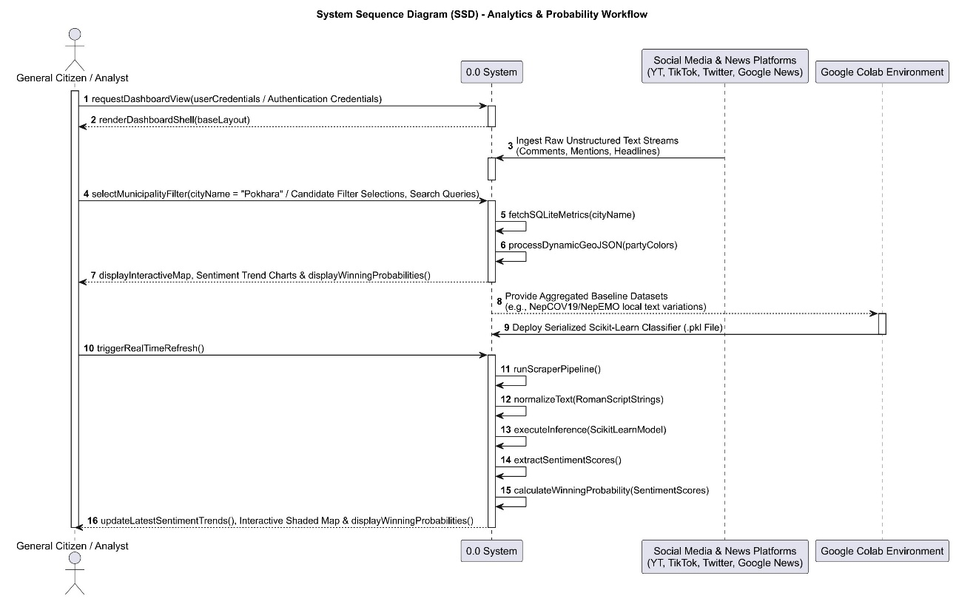
3.5. ENTITY RELATIONSHIP DIAGRAM
An entity relationship diagram (ERD), also known as an entity relationship model, is a graphical representation of the relationships that exist between people, objects, places, concepts, or events in an information technology (IT) system. An ERD employs data modeling techniques to assist in the definition of business processes and as the foundation for a relational database.
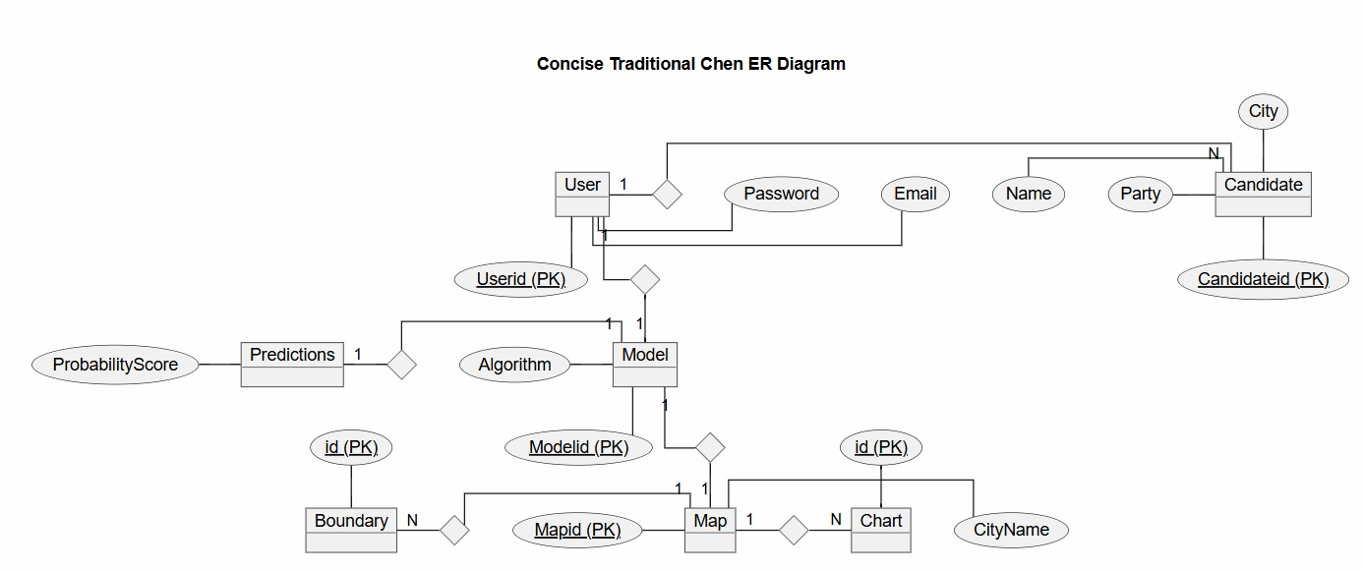

CHAPTER 4
EXPECTED OUTPUTS
We forecast the outcome of this project to be a fully functional web-based platform that provides users with an interactive geographical map and election sentiment trends extracted from AI. Users will be able to analyze public opinion patterns through a user-friendly interface and visualize candidate winning probabilities in five major cities rendered dynamically using Leaflet.js. Additional features such as multi-platform social media scraping, background text-cleaning modules that standardize mixed Roman script commentary, and dynamic municipal boundary shading improve the user experience. The system will output accurate data-specific outputs which will make the process of tracking public sentiment and analyzing elections from data collection to visualization easier.

CHAPTER 5
TIMELINE CHART
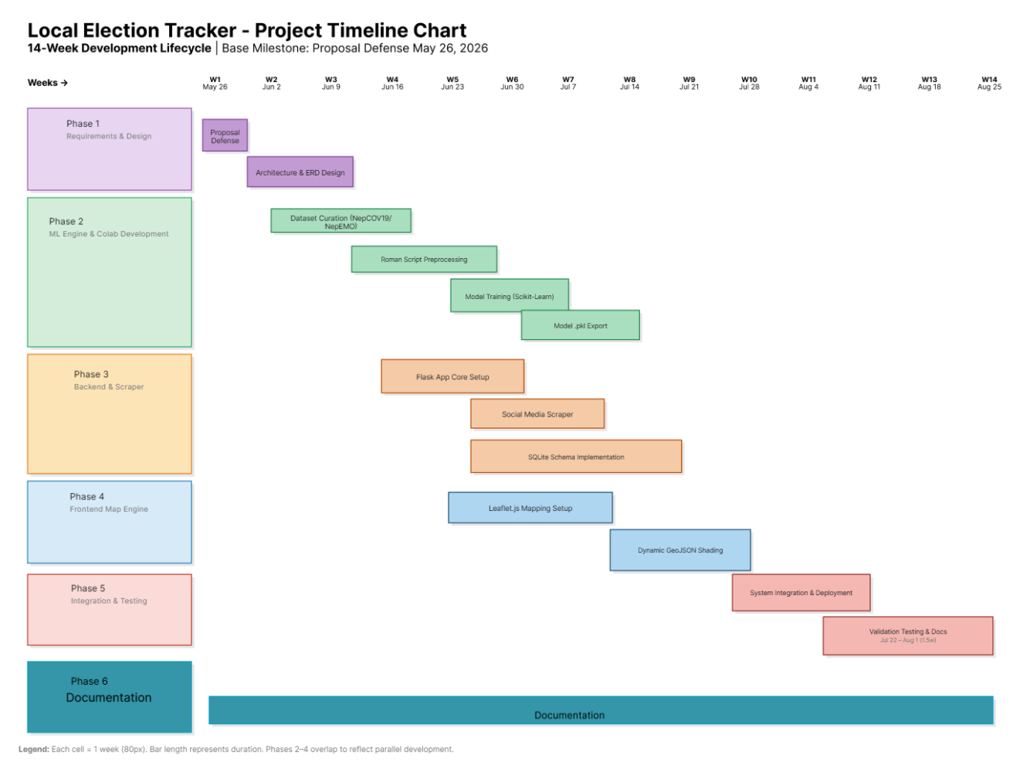

Bibliography
Regmi, D. (2020, 1 1). 6 Challenges for Mobile Banking Apps in Nepal. (investopaper.com) Retrieved 01 15, 2022, from https://www.investopaper.com/news/6-challenges-for-mobile-banking-apps-in-nepal/

